Lab 8

P1: To Interface a Stepper Motor to 8086 Microprocessor through 8255 Programmable Peripheral Controller using Proteus

Code:

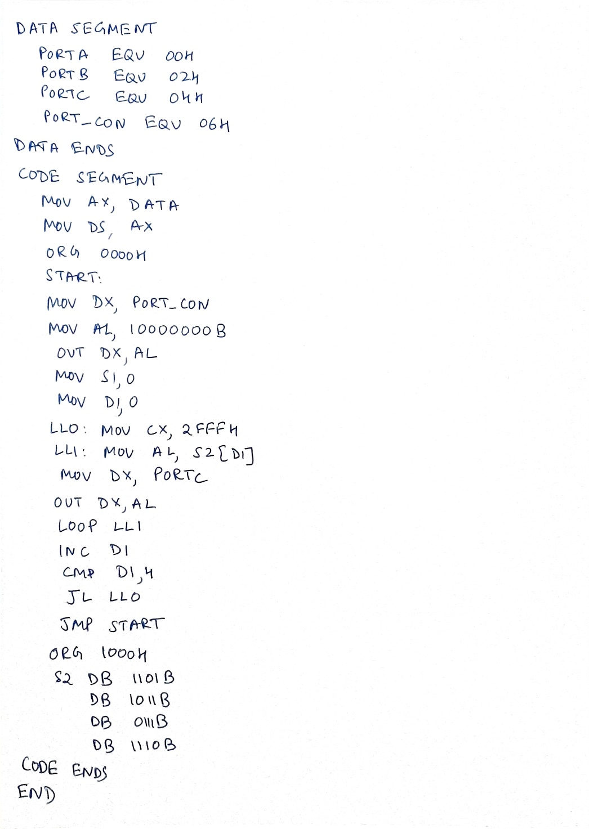

Circuit Diagram:

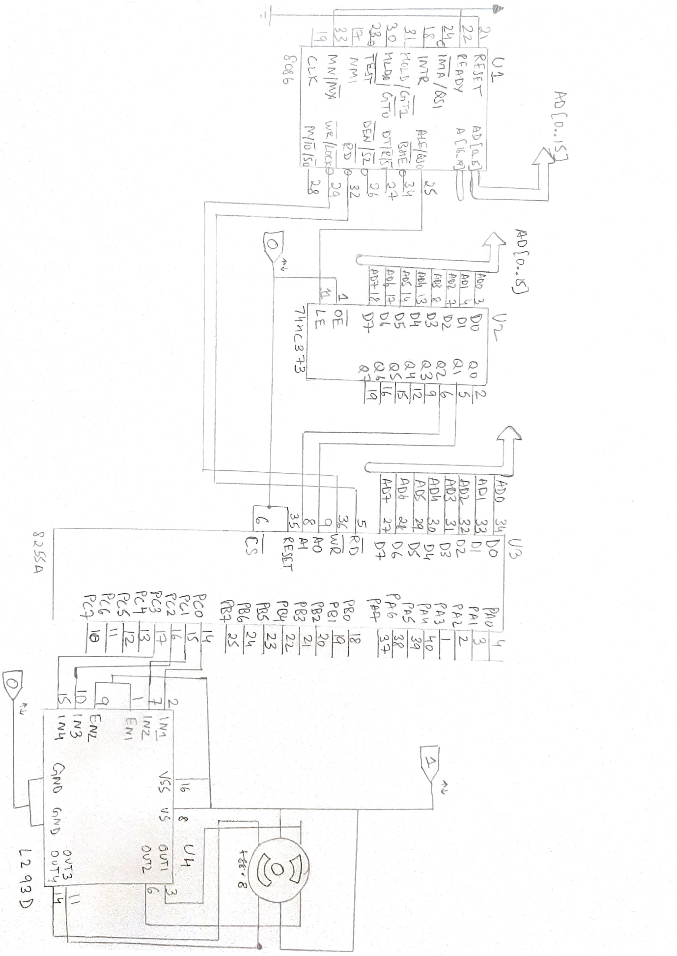

Output:

